M.NAEEM KAYANI
BSE231102
SCD Lab 13
Section 01
PRACTICE TASK
Calculator.JAVA
public class Calculator {

public int add(int a, int b) {
return a + b;
}

public int subtract(int a, int b) {
return a - b;
}

public int multiply(int a, int b) {
return a * b;
}

public double divide(int a, int b) {
if (b == 0) {
throw new IllegalArgumentException("Division by zero is not allowed");
}
return (double) a / b;
}

public double power(int base, int exponent) {
return Math.pow(base, exponent);
}
}

CalculatorTest.JAVA

import static org.junit.Assert.*;
import org.junit.Before;
import org.junit.After;
import org.junit.Test;

public class CalculatorTest {

Calculator calc;

@Before
public void setUp() {
calc = new Calculator();
}

@Test
public void testAddition() {
assertEquals(10, calc.add(7, 3));
}

@Test
public void testSubtraction() {
assertEquals(4, calc.subtract(7, 3));
}

@Test
public void testMultiplication() {
assertEquals(21, calc.multiply(7, 3));
}

@Test
public void testDivision() {
assertEquals(2.0, calc.divide(6, 3), 0.001);
}

@Test
public void testPower() {
assertEquals(8.0, calc.power(2, 3), 0.001);
}

@Test
public void testAdditionWithNegativeNumbers() {
assertEquals(-2, calc.add(-5, 3));
}

@Test
public void testMultiplicationWithNegativeNumbers() {
assertEquals(-15, calc.multiply(-5, 3));
}

@Test(expected = IllegalArgumentException.class)
public void testDivisionByZero() {
calc.divide(10, 0);
}

@After
public void tearDown() {
calc = null;
}
}

OUTPUT:
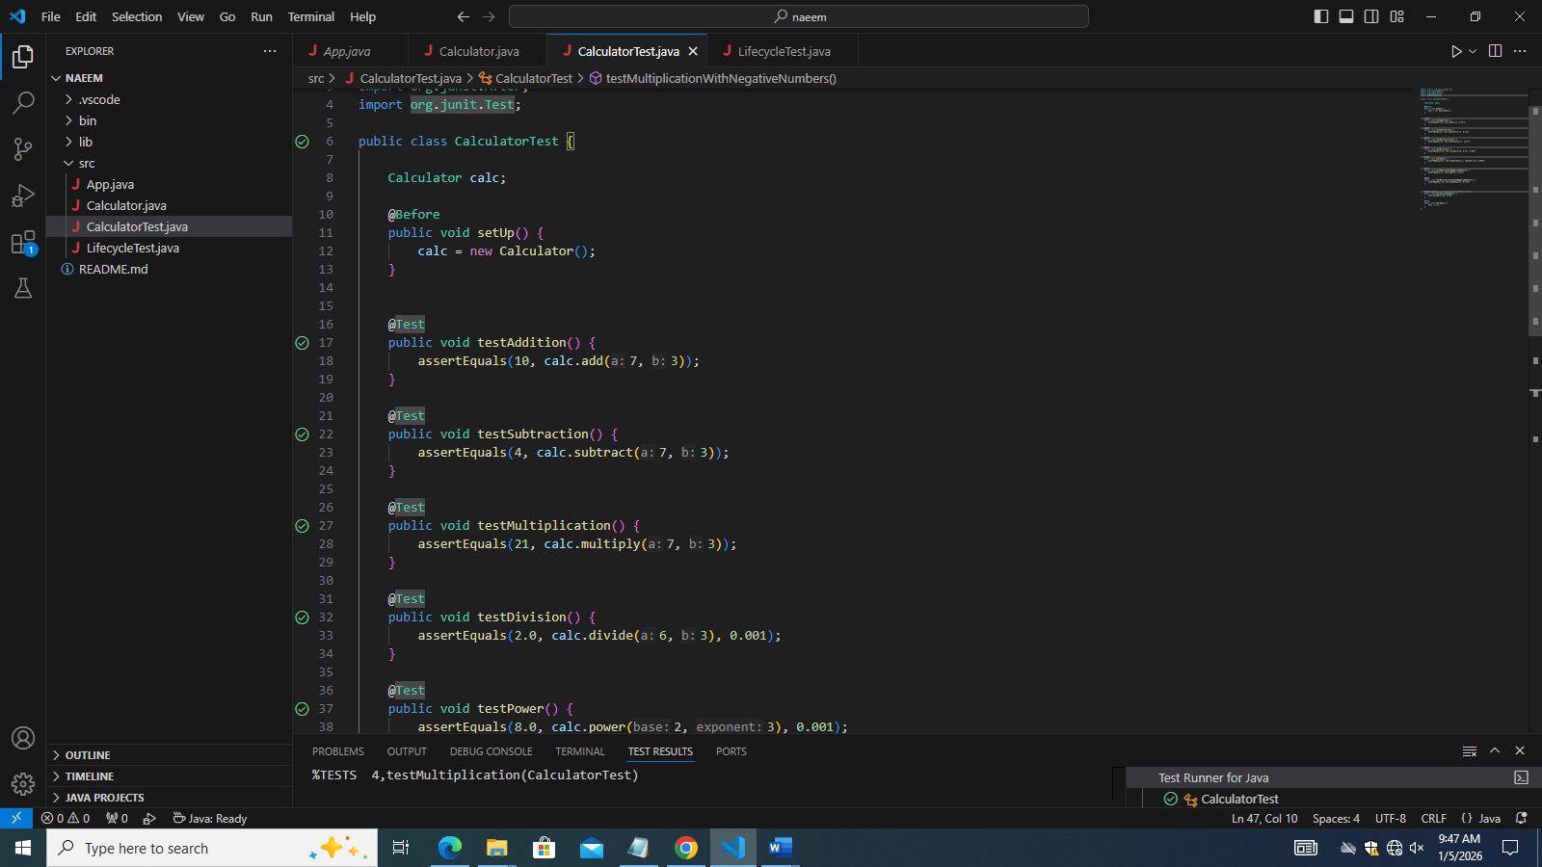

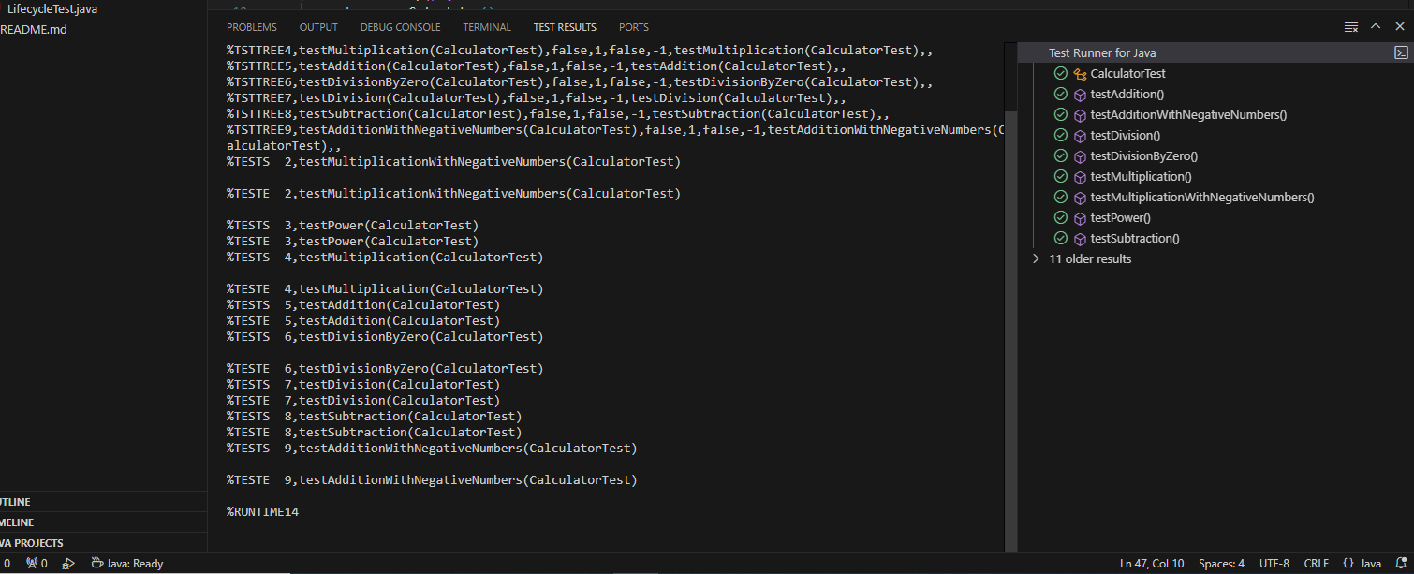

PRACTICE TASK 2:
StudentResult.JAVA
public class StudentResult {

private int[] marks;
private static final int MAX_MARK = 100;

public StudentResult(int[] marks) {
if (marks == null || marks.length == 0) {
throw new IllegalArgumentException("Marks cannot be empty");
}

for (int mark : marks) {
if (mark < 0 || mark > MAX_MARK) {
throw new IllegalArgumentException("Invalid marks value");
}
}
this.marks = marks;
}

public int calculateTotal() {
int total = 0;
for (int mark : marks) {
total += mark;
}
return total;
}

public double calculateAverage() {
return (double) calculateTotal() / marks.length;
}

public boolean isPass() {
return calculateAverage() >= 40;
}

public String getGrade() {
double avg = calculateAverage();

if (avg >= 85) return "A";
else if (avg >= 70) return "B";
else if (avg >= 55) return "C";
else if (avg >= 40) return "D";
else return "F";
}
}

StudentResultTest.JAVA

import static org.junit.Assert.*;
import org.junit.Test;

public class StudentResultTest {

@Test
public void testTotalMarks() {
int[] marks = {70, 80, 90};
StudentResult sr = new StudentResult(marks);
assertEquals(240, sr.calculateTotal());
}

@Test
public void testAverageMarks() {
int[] marks = {60, 70, 80};
StudentResult sr = new StudentResult(marks);
assertEquals(70.0, sr.calculateAverage(), 0.01);
}

@Test
public void testPassStatus() {
int[] marks = {50, 60, 70};
StudentResult sr = new StudentResult(marks);
assertTrue(sr.isPass());
}

@Test
public void testFailStatus() {
int[] marks = {20, 30, 35};
StudentResult sr = new StudentResult(marks);
assertFalse(sr.isPass());
}

@Test
public void testGradeA() {
int[] marks = {90, 85, 88};
StudentResult sr = new StudentResult(marks);
assertEquals("A", sr.getGrade());
}

@Test
public void testGradeC() {
int[] marks = {55, 60, 58};
StudentResult sr = new StudentResult(marks);
assertEquals("C", sr.getGrade());
}

@Test(expected = IllegalArgumentException.class)
public void testNegativeMarks() {
int[] marks = {60, -10, 70};
new StudentResult(marks);
}

@Test(expected = IllegalArgumentException.class)
public void testMarksGreaterThanMax() {
int[] marks = {90, 110, 80};
new StudentResult(marks);
}

@Test(expected = IllegalArgumentException.class)
public void testEmptyMarks() {
int[] marks = {};
new StudentResult(marks);
}

@Test
public void testMinimumBoundary() {
int[] marks = {40, 40, 40};
StudentResult sr = new StudentResult(marks);
assertTrue(sr.isPass());
assertEquals("D", sr.getGrade());
}

@Test
public void testMaximumBoundary() {
int[] marks = {100, 100, 100};
StudentResult sr = new StudentResult(marks);
assertEquals("A", sr.getGrade());
}
}

OUTPUT:
